Before You Begin

PuTTy설정을 통해 VM 과 연결하고 VNC 서버를 기동하는 방법을 기술한다.

What Do You Need?

* Your Oracle Cloud account
* gitbash
* Your private key in a [PuTTy-compatible or OpenSSH format](https://apexapps.oracle.com/pls/apex/f?p=44785:24:8234694798104::NO:RP,24:P24_CONTENT_ID,P24_PREV_PAGE:18852,2)
* VNC Viewer

# **사전 준비 사항**

1. OCI Compute 에서 인스턴스 생성
2. VNC Viewer 설치
3. VGA Console 인증을 위한 Key pair (Pubic / Private)   
   (인스턴스 생성시 사용한 Key pair를 다시 사용해도 됩니다)

section 1 Public IP 확인

1. 오라클 클라우드에 sign in 한 후 Public IP를 가진 VM 인스턴스를 생성한다.

[Description of the illustration 01_002_selectinstance.png](https://docs.oracle.com/en/cloud/paas/data-integration-platform-cloud/tutorial-odi-vnc/files/01_002_selectinstance.txt)

1. 인스턴스 상세정보 the **Public IP를 확인한다.**

[Description of the illustration 01_003_publicIP.png](https://docs.oracle.com/en/cloud/paas/data-integration-platform-cloud/tutorial-odi-vnc/files/01_003_publicIP.txt)

section 2 Listening Port 확인

1. gitbash를 열어 Public IP로 VM 인스턴스에 접속한다. (ssh opc@public ip)
2. sudo bash or sudo –i or sudo -s

GUI가 설치되어 있는지 확인

[root@vnc opc]# yum grouplist | grep GUI

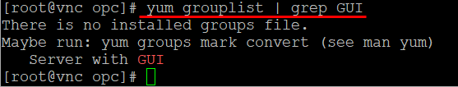

Oracle cloud 인스턴스에는 기본적으로 GUI (X Window)가 설치되어 있지 않다.

1. [root@vnc opc]# yum group install "Server with GUI" –y 🡪 오래걸림(역 5분. 4분 40초)

원격접속 서버(VNC) 설치

1. [root@vnc opc]# yum install tigervnc-server –y
   * VNC는 GUI 환경으로 원격 관리
2. [root@vnc opc]# exit
3. [opc@vnc ~]$vncpasswd

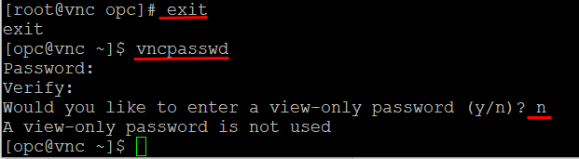

**vncpasswd** allows you to set the password used to access VNC desktops.

The **vncserver** script runs **vncpasswd** the first time you start a VNC desktop, and it invokes **Xvnc** with the appropriate **-rfbauth** option. **vncviewer** can also be given a password file to use via the **-passwd** option.

1. sudo bash
2. cp -p /lib/systemd/system/vncserver@.service [/etc/systemd/system/vncserver@\:1.service](mailto:/etc/systemd/system/vncserver@\:1.service)
3. vi [/etc/systemd/system/vncserver@\:1.service](mailto:/etc/systemd/system/vncserver@\:1.service)

<USER> 2개 opc로 수정

1. [root@bastion opc]# systemctl daemon-reload
2. [root@bastion opc]# systemctl enable vncserver@\:1.service
3. [root@bastion opc]# systemctl start vncserver@\:1.service
4. [root@bastion opc]# systemctl status vncserver@\:1.service
5. vnc 서버 기동
6. [opc@vnc ~]$ vncserver
7. $ vncserver –nolock 🡪 이 옵션은 머지? 일단 무시

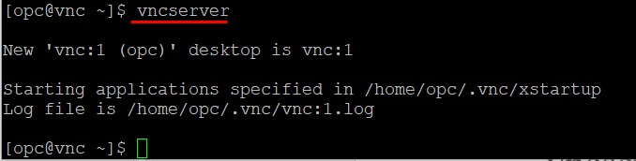

1. 참고

### vncserver 실행 및 종료

|  |  |
| --- | --- |
| 1 2 3 4 5 6 7 8 | # 서버 실행 vncserver  # 해상도 지정 후 서버 실행 vncserver -geometry 1920x1080  # 서버 종료, 콜론도 꼭 붙여 줘야 한다. kill 옵션 다음에 한 칸 띈다. vncserver -kill :[Display 번호] |

1. Verify that VNC Server is running:

$ ps -ef |grep vnc

1. Verify the listening port:

$ netstat -tulpn

Take note of the port number. For the purposes of this tutorial, the listening port number is 5901.

1. (Optional) Use Telnet to test the connection:

$ sudo yum install telnet

$ telnet 127.0.0.1 <listening_port_number>

1. Close the PuTTy window.

section 3Configuring PuTTy to Connect to Your VM and Start VNC server

1. Open PuTTy.
2. Enter your instance's Public IP address into the **Host Name** field. 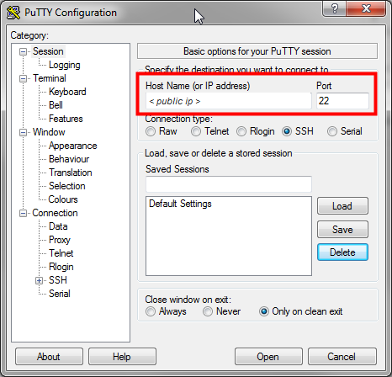[Description of the illustration 02_001.png](https://docs.oracle.com/en/cloud/paas/data-integration-platform-cloud/tutorial-odi-vnc/files/02_001_puttyconfig.txt)
3. In the **Category** pane, expand **Connection,** select **Data,** and then enter opc in the **Auto-login username** field. 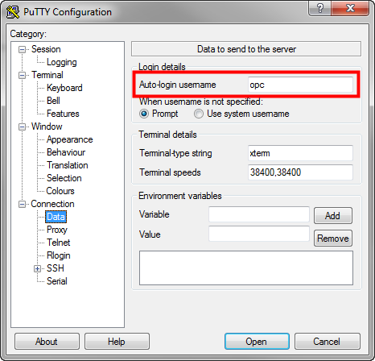[Description of the illustration 02_002_puttyconfig.png](https://docs.oracle.com/en/cloud/paas/data-integration-platform-cloud/tutorial-odi-vnc/files/02_002_puttyconfig.txt)
4. In the **Category** pane, under **Connection,** expand **SSH,** and select **Tunnels.**
5. Enter the listening port number for VNC Server in the **Source port** field and 127.0.0.1:<listening_port_number> into the Destination field, then click **Add.** 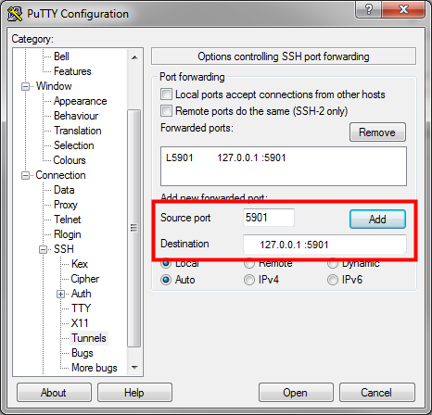[Description of the illustration 02_003.png](https://docs.oracle.com/en/cloud/paas/data-integration-platform-cloud/tutorial-odi-vnc/files/02_003_puttyconfig.txt)
6. In the **Category** pane, under **SSH,** select **Auth.**
7. For **Private key file for authentication,** click **Browse** and locate your private key. 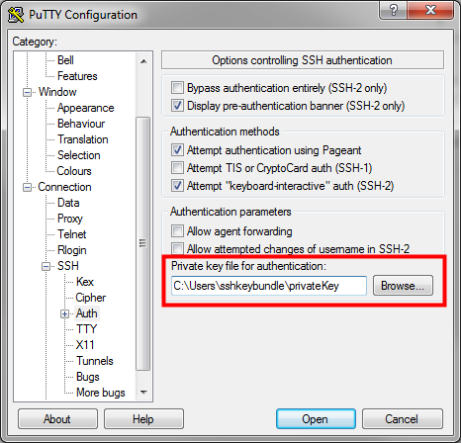[Description of the illustration 02_004_puttyconfig.png](https://docs.oracle.com/en/cloud/paas/data-integration-platform-cloud/tutorial-odi-vnc/files/02_004_puttyconfig.txt)
8. In the **Category** pane, select **Session,** and then enter a name for this session under **Saved Sessions** and click **Save.** 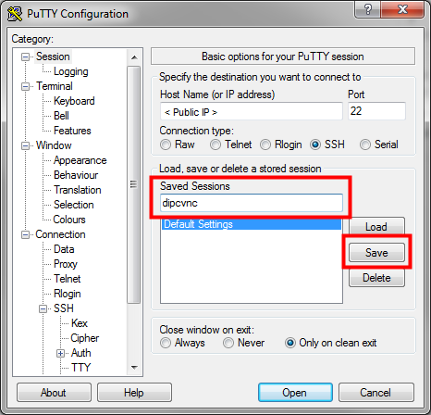[Description of the illustration 02_005_puttyconfig.png](https://docs.oracle.com/en/cloud/paas/data-integration-platform-cloud/tutorial-odi-vnc/files/02_005_puttyconfig.txt)
9. Click **Open** to establish the connection.
10. After you've successfully connected, enter the following command to switch to the oracle user:

$ sudo su - oracle

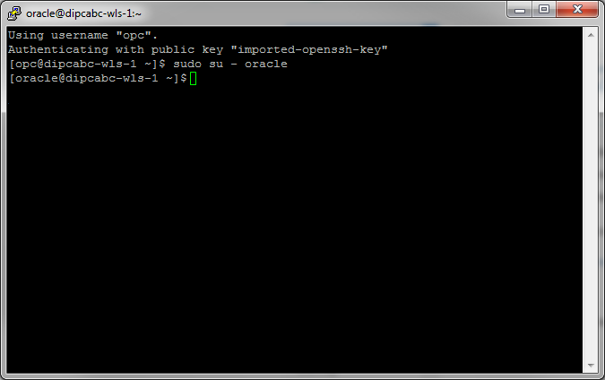[Description of the illustration 02_006a_putty.png](https://docs.oracle.com/en/cloud/paas/data-integration-platform-cloud/tutorial-odi-vnc/files/02_006a_putty.txt)

1. Enter the following command to start VNC server:

$ vncserver -nolock

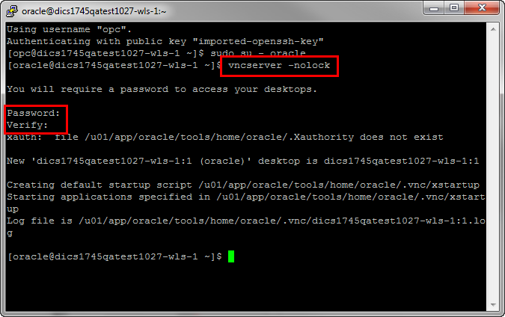[Description of the illustration 02_007_putty.png](https://docs.oracle.com/en/cloud/paas/data-integration-platform-cloud/tutorial-odi-vnc/files/02_007_putty.txt)

If you're prompted to enter a password to connect to the VNC server, enter a password and confirm the password. VNC server will start automatically.

The SSH tunnel redirects the VNC output of your VM to localhost (127.0.0.1).

1. Open Tiger VNC Viewer, enter 127.0.0.1:<listening_port_number> in the **VNC server** field, and then click **Connect.** 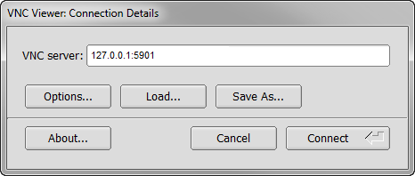[Description of the illustration 02_008_vncviewer.png](https://docs.oracle.com/en/cloud/paas/data-integration-platform-cloud/tutorial-odi-vnc/files/02_008_vncviewer.txt)
2. Enter the password that you set in step 11 and click **OK.**

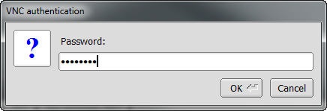[Description of the illustration 02_009_vncviewer.png](https://docs.oracle.com/en/cloud/paas/data-integration-platform-cloud/tutorial-odi-vnc/files/02_009_vncviewer.txt)

1. After you've successfully connected to your VM with VNC viewer, your desktop appears similar to the following: 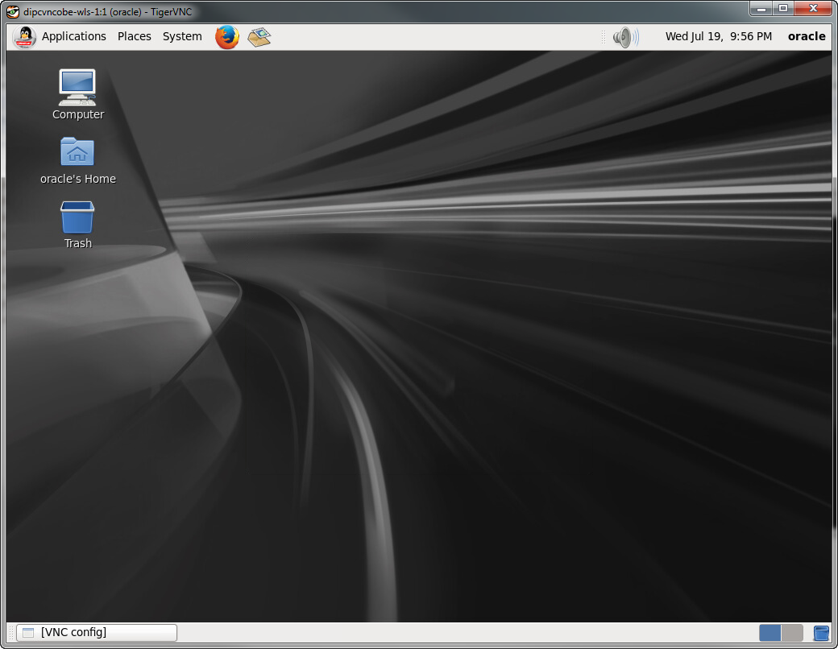[Description of the illustration 02_010_vncviewer.png](https://docs.oracle.com/en/cloud/paas/data-integration-platform-cloud/tutorial-odi-vnc/files/02_010_vncviewer.txt)
2. (Optional) Disable the screen saver to avoid getting locked out of the instance. In the **System** menu, go to **Preferences**, and select **Screensaver.** Deselect **Activate screensaver when the computer is idle,** and then click **Close.** 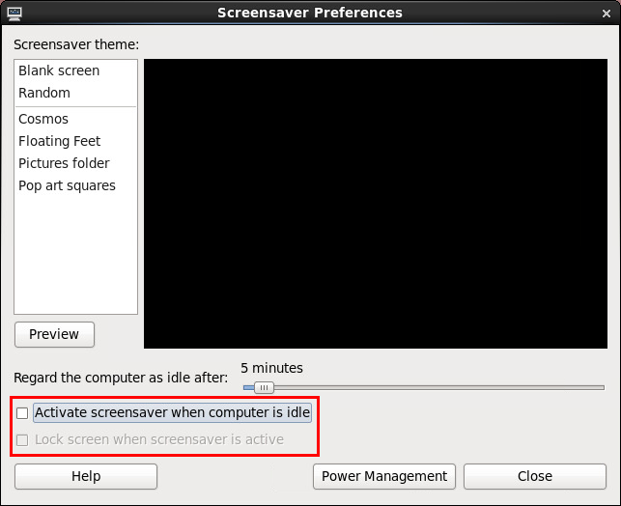[Description of the illustration 02_011_screensaver.png](https://docs.oracle.com/en/cloud/paas/data-integration-platform-cloud/tutorial-odi-vnc/files/02_011_screensaver.txt)

Alternatively, you can set a password for the opc user.

section 4Launching Oracle Data Integrator 12*c* Studio

1. Open a Terminal window and enter the following:

/u01/app/oracle/suite/suite_mw/odi_studio/odi/studio/bin/odi

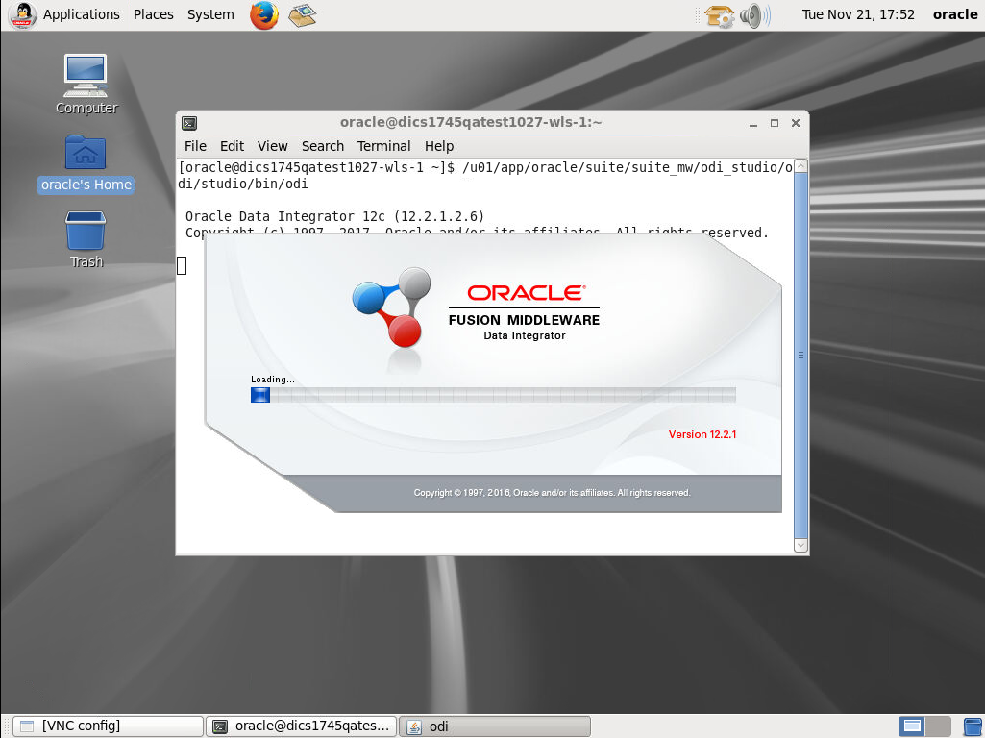[Description of the illustration 03_001.png](https://docs.oracle.com/en/cloud/paas/data-integration-platform-cloud/tutorial-odi-vnc/files/03_001.txt)

1. Oracle Data Integrator Studio 12*c* starts and is ready to use. 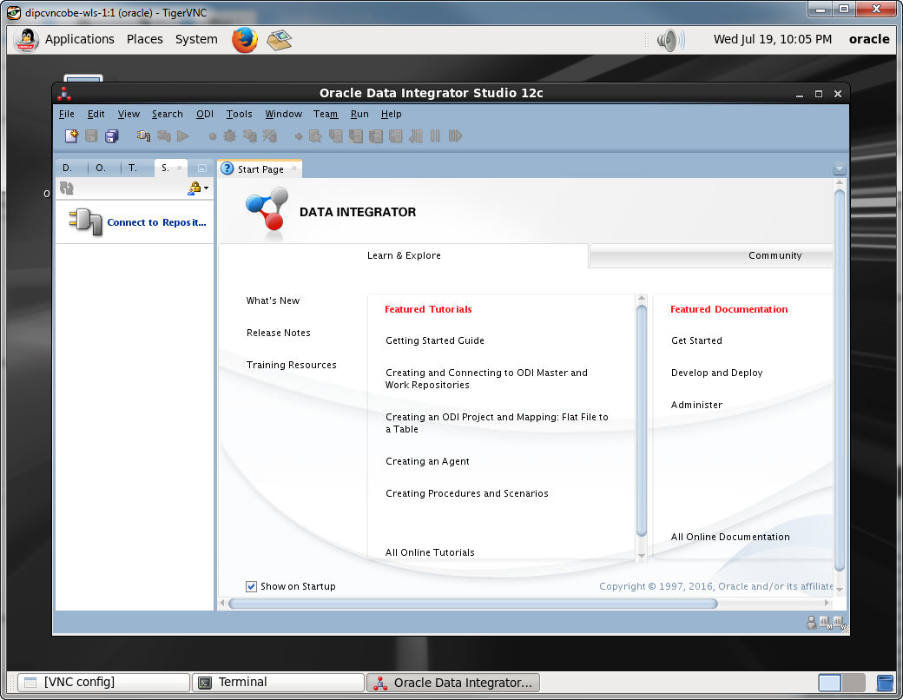[Description of the illustration 03_002.png](https://docs.oracle.com/en/cloud/paas/data-integration-platform-cloud/tutorial-odi-vnc/files/03_002.txt)

section 5Granting users access to ODI Studio

1. Using Identity Cloud, you can assign roles to users to access ODI Studio through Data Integration Platform. You can assign any of the following roles:
   * **Administrator** (Service application administrator role), which is equivalent to **ODI Supervisor**
   * **Developer** (Service application developer role), which is equivalent to **ODI Designer**
   * **User** (Service application user role), which is equivalent to **ODI Operator**

For more information on how to assign roles to users, see [Manage Security for Services Instances.](https://apexapps.oracle.com/pls/apex/f?p=44785:112:0::::P112_CONTENT_ID:21259)

section 6Connecting to the ODI Repository

1. From your Oracle Cloud Service Console, locate your service instance, and then from the **Manage this Service** menu, select **Open WebLogic Server Console.** 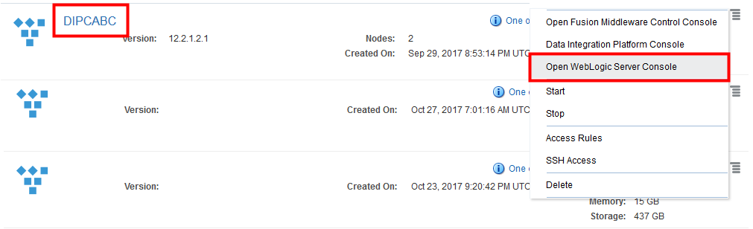[Description of the illustration 05_001.png](https://docs.oracle.com/en/cloud/paas/data-integration-platform-cloud/tutorial-odi-vnc/files/05_001.txt)
2. Log in to the WebLogic Server Console. 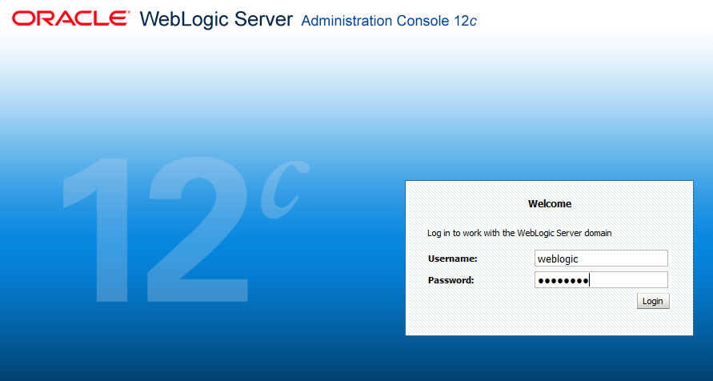[Description of the illustration 05_002.png](https://docs.oracle.com/en/cloud/paas/data-integration-platform-cloud/tutorial-odi-vnc/files/05_002.txt)
3. In the Change Center panel, click **Lock & Edit.** 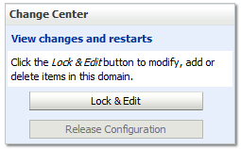[Description of the illustration 05_003.png](https://docs.oracle.com/en/cloud/paas/data-integration-platform-cloud/tutorial-odi-vnc/files/05_003.txt)
4. In Domain Structure, expand **Services,** and then click **Data Sources.** 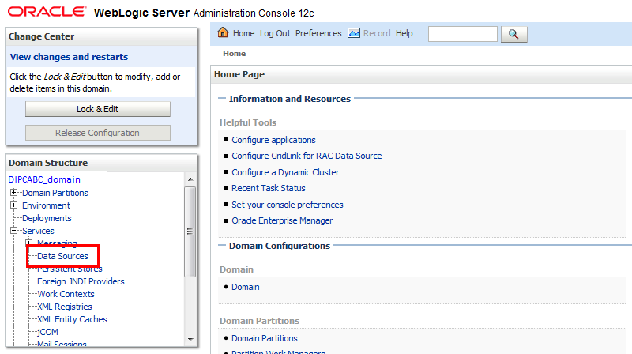[Description of the illustration 05_004.png](https://docs.oracle.com/en/cloud/paas/data-integration-platform-cloud/tutorial-odi-vnc/files/05_004.txt)
5. Select **odiMasterRepository** from the list of Data Sources. 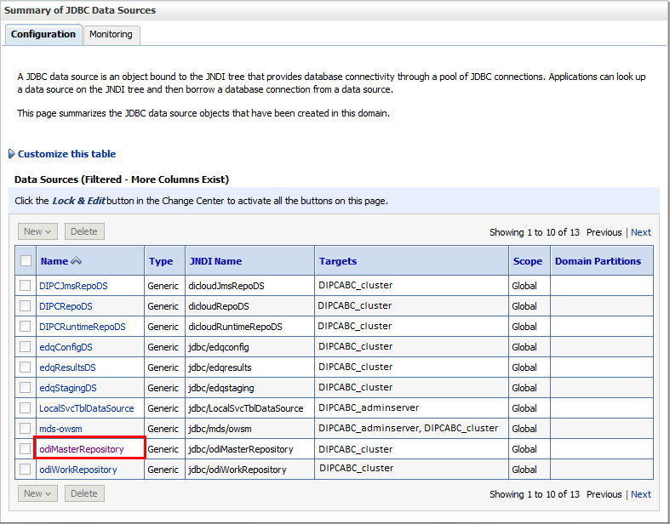[Description of the illustration 05_005.png](https://docs.oracle.com/en/cloud/paas/data-integration-platform-cloud/tutorial-odi-vnc/files/05_005.txt)
6. Under Settings for odiMasterRepository, click **Connection Pool,** and then copy the user and URL values. 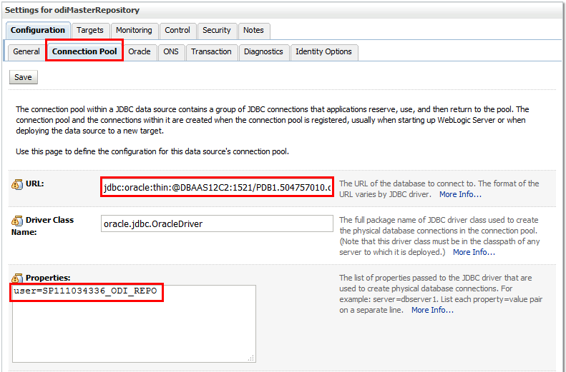[Description of the illustration 05_006.png](https://docs.oracle.com/en/cloud/paas/data-integration-platform-cloud/tutorial-odi-vnc/files/05_006.txt)
7. Back in ODI Studio, click **Connect to Repository.** 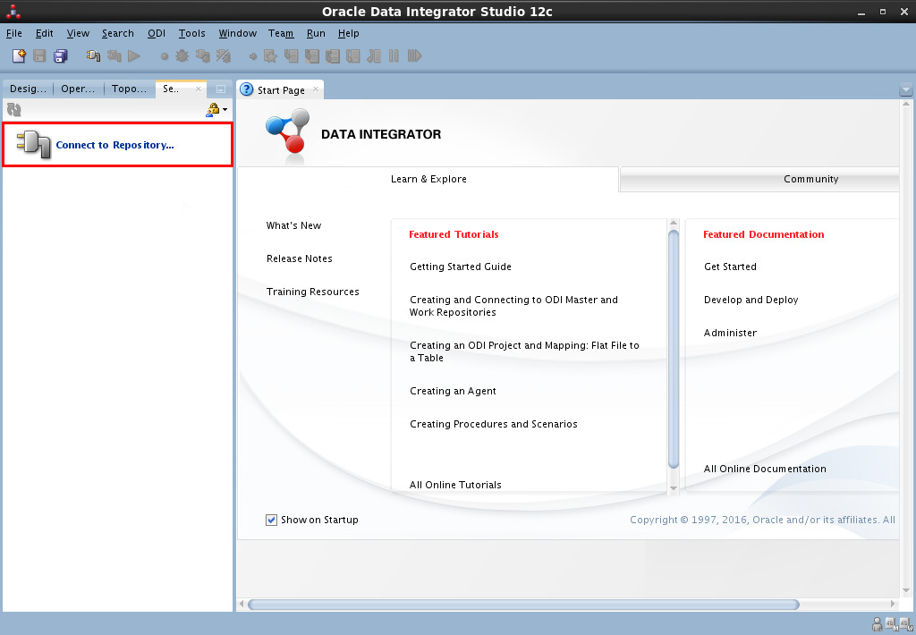[Description of the illustration 05_007.png](https://docs.oracle.com/en/cloud/paas/data-integration-platform-cloud/tutorial-odi-vnc/files/05_007.txt)
8. In the Oracle Data Integrator Login dialog, click **New.** 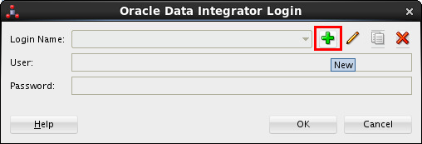[Description of the illustration 05_008.png](https://docs.oracle.com/en/cloud/paas/data-integration-platform-cloud/tutorial-odi-vnc/files/05_008.txt)
9. In the Repository Connection Information dialog, complete the fields. Paste the user and URL values from the WebLogic Server Console into the User and URL fields in the Database Connection (Master Repository) section. Use your WebLogic Server as the Master Repository password. 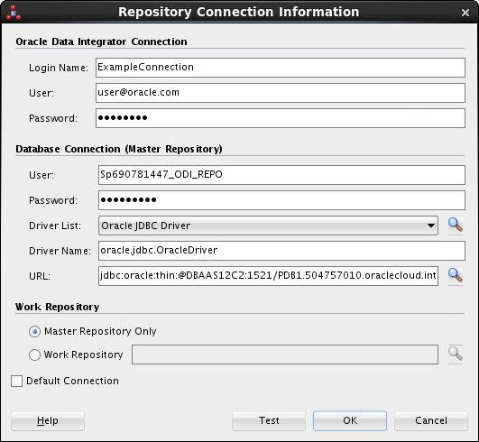[Description of the illustration 05_009.png](https://docs.oracle.com/en/cloud/paas/data-integration-platform-cloud/tutorial-odi-vnc/files/05_009.txt)
10. Click **Test** to test the connection details. If successful, click **OK.** If not successful, go back to the WebLogic Server Console to check your user and URL details.

more informationWant to Learn More?

* [Data Integration Platform Cloud on Oracle Help Center](http://docs.oracle.com/en/cloud/paas/data-integration-platform-cloud/index.html)
* [Oracle Data Integrator on Oracle Help Center](http://docs.oracle.com/middleware/12212/odi/index.html)